Test Case: tc001_SPX_Dev5_Crear_Solicitud_Articulo_Almacen
Step 1 - Enter username and password and click to button Enter : Credentials Entered
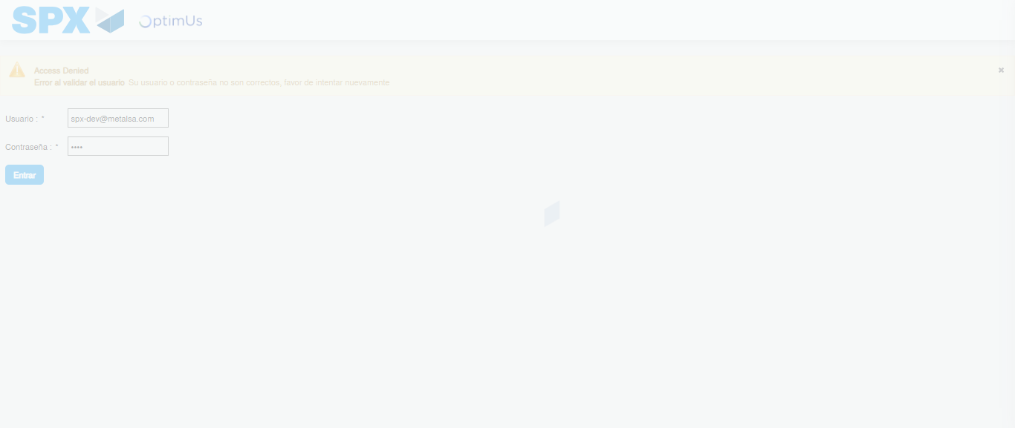Image file-name: QC_Testing-tc001_SPX_Dev5_Crear_Solicitud_Articulo_Almacen-1788279730953

Step 2 - Select to UEN and Access to Request for a New Inventory Item : UEN Correctly selected and Correct access
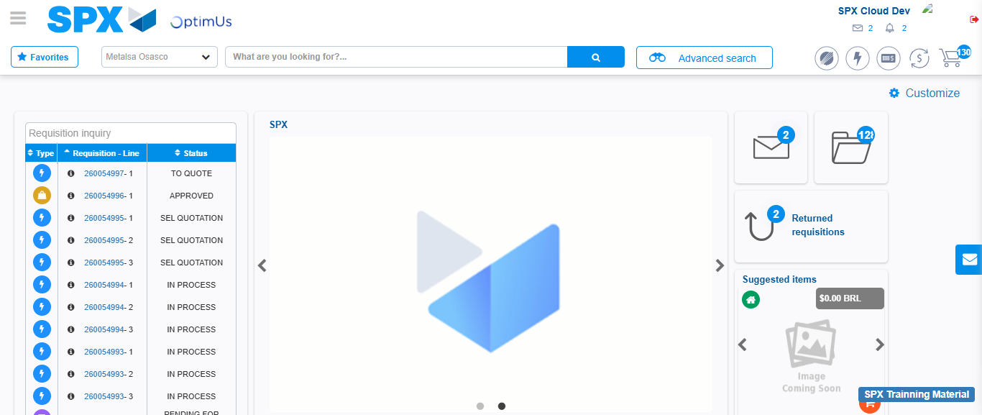Image file-name: QC_Testing-tc001_SPX_Dev5_Crear_Solicitud_Articulo_Almacen-1788279757831

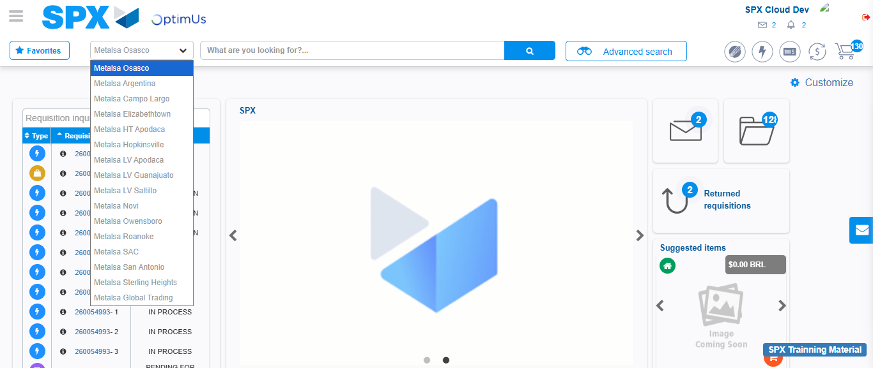Image file-name: QC_Testing-tc001_SPX_Dev5_Crear_Solicitud_Articulo_Almacen-1788279758783

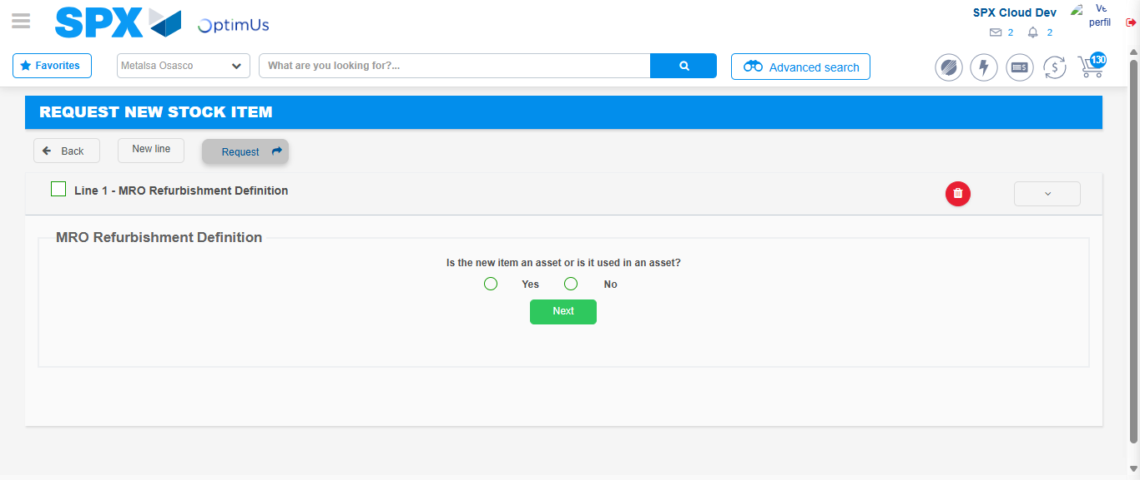Image file-name: QC_Testing-tc001_SPX_Dev5_Crear_Solicitud_Articulo_Almacen-1788279779263

Step 3 - Select options first section : Options seleted correctly
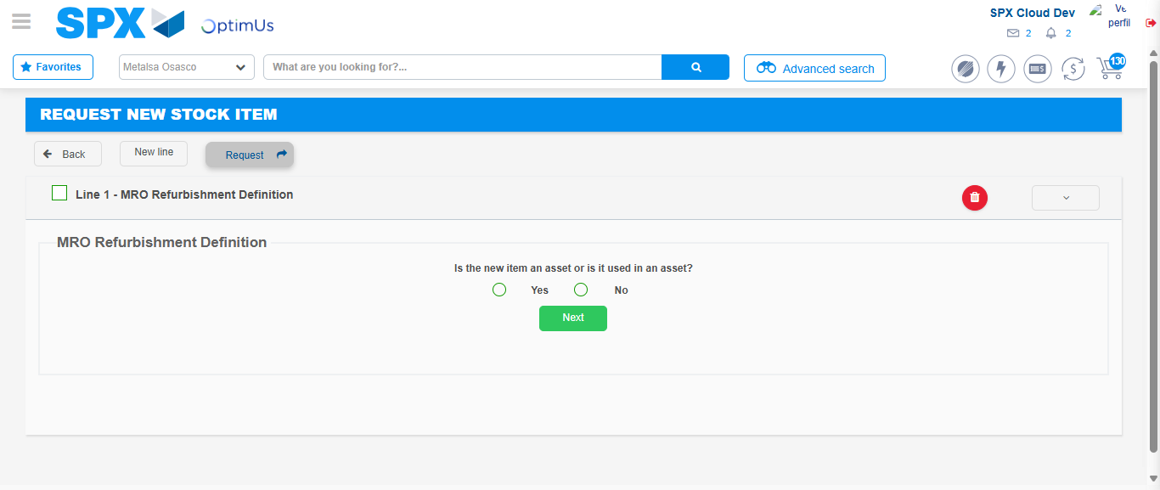Image file-name: QC_Testing-tc001_SPX_Dev5_Crear_Solicitud_Articulo_Almacen-1788279779611

Image file-name: QC_Testing-tc001_SPX_Dev5_Crear_Solicitud_Articulo_Almacen-1788279779872

Step 4 - Select options at Screen: Options seleted correctly
Image file-name: QC_Testing-tc001_SPX_Dev5_Crear_Solicitud_Articulo_Almacen-1788279779611

Image file-name: QC_Testing-tc001_SPX_Dev5_Crear_Solicitud_Articulo_Almacen-1788279779872

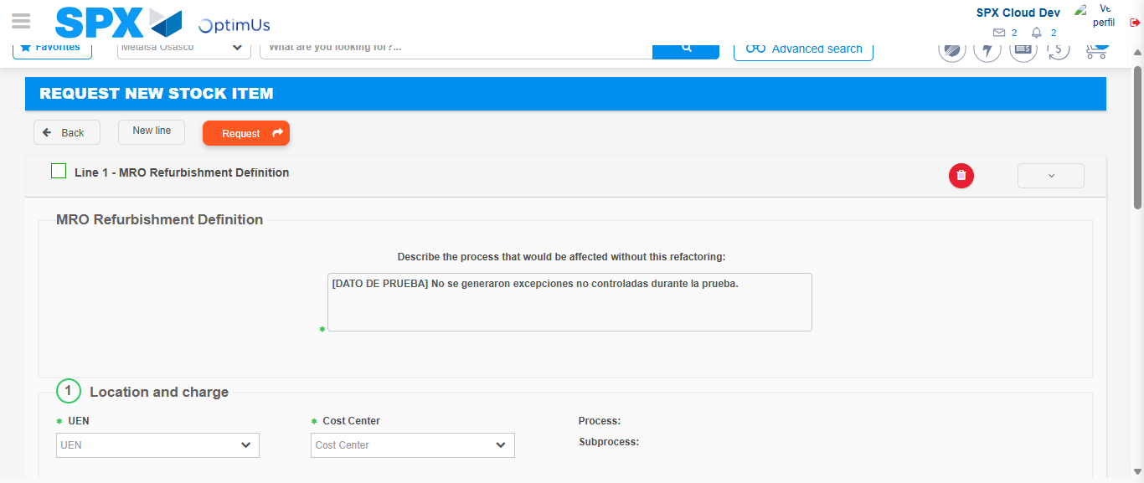Image file-name: QC_Testing-tc001_SPX_Dev5_Crear_Solicitud_Articulo_Almacen-1788279793104

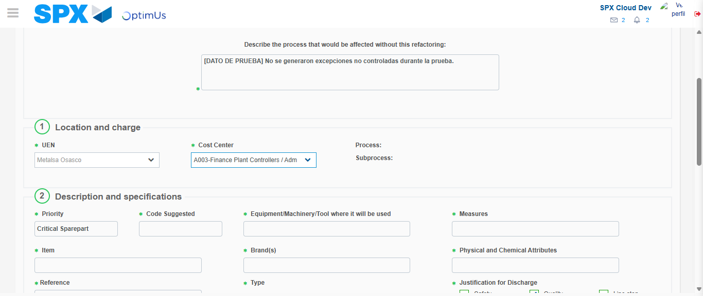Image file-name: QC_Testing-tc001_SPX_Dev5_Crear_Solicitud_Articulo_Almacen-1788279796497

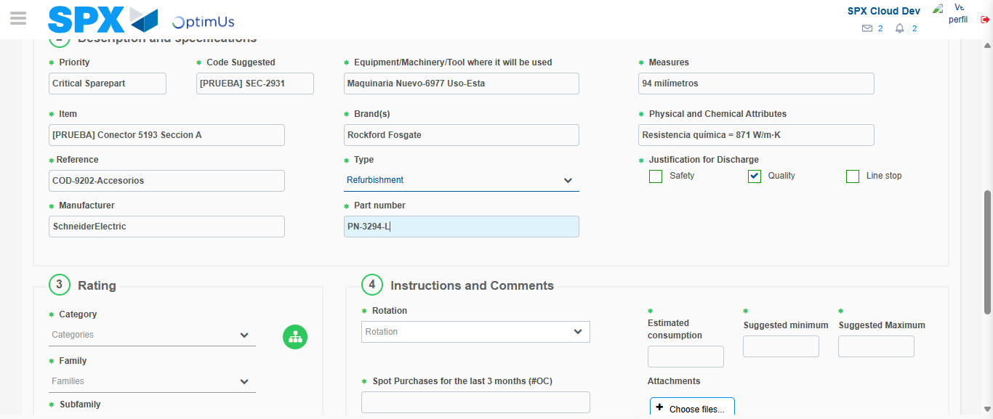Image file-name: QC_Testing-tc001_SPX_Dev5_Crear_Solicitud_Articulo_Almacen-1788279799330

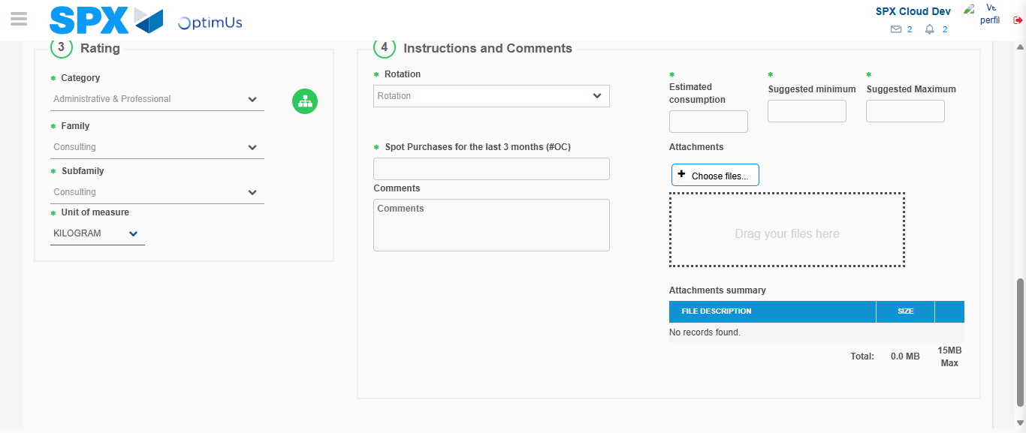Image file-name: QC_Testing-tc001_SPX_Dev5_Crear_Solicitud_Articulo_Almacen-1788279804988

Step 5 - Request New Item : Request Accepted
Image file-name: QC_Testing-tc001_SPX_Dev5_Crear_Solicitud_Articulo_Almacen-1788279757831

Image file-name: QC_Testing-tc001_SPX_Dev5_Crear_Solicitud_Articulo_Almacen-1788279758783

Image file-name: QC_Testing-tc001_SPX_Dev5_Crear_Solicitud_Articulo_Almacen-1788279779263

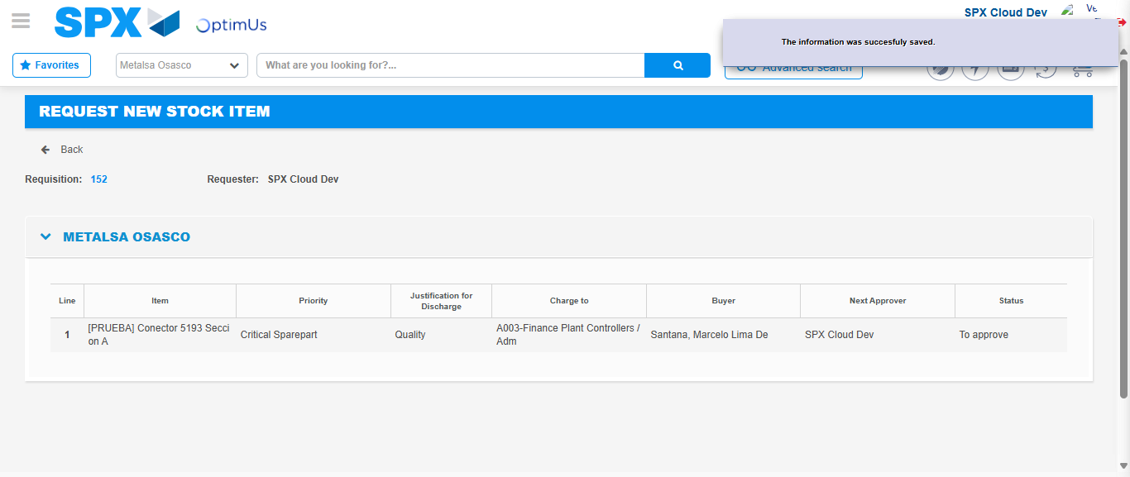Image file-name: QC_Testing-tc001_SPX_Dev5_Crear_Solicitud_Articulo_Almacen-1788279813878

Image file-name: QC_Testing-tc001_SPX_Dev5_Crear_Solicitud_Articulo_Almacen-1788279814132

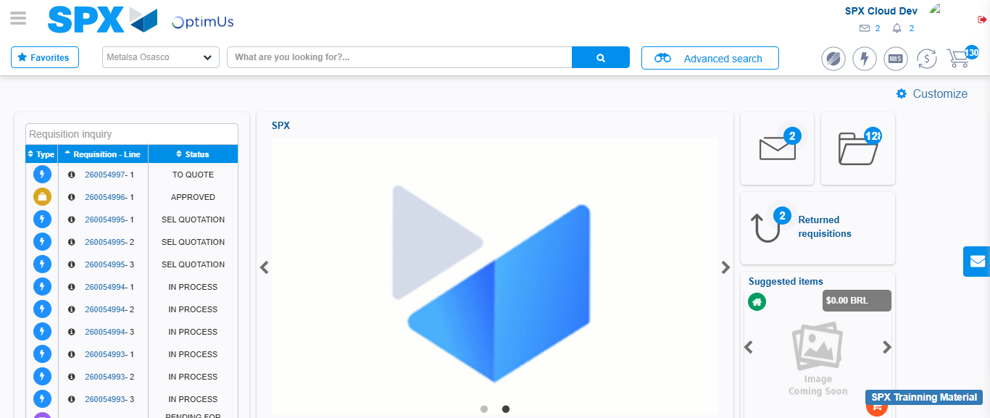Image file-name: QC_Testing-tc001_SPX_Dev5_Crear_Solicitud_Articulo_Almacen-1788279835771

Step 7 - Return to Main Page SPX : Return to Main Page SPX
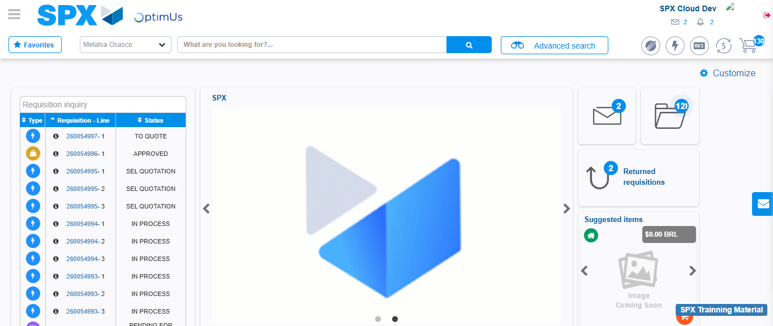Image file-name: QC_Testing-tc001_SPX_Dev5_Crear_Solicitud_Articulo_Almacen-1788279836264

